

MARMARA UNIVERSITY
FACULTY OF ENGINEERING
PHYS1104
PHYSICS LABORATORY II

EXPERIMENT 5
Capacitor Charge and Discharge

Section: PHYS1104
Submitted to: Prof. Dr. MURAT DOĞRUEL

 | Department | Id Number | Name & Surname | Contribution
1 | EEE |  | Onur | Conclusion, Questions
2 | EEE | 150720062 | Mehmet Ali Kamalak | Purpose, Theory, Preparing Document, Calculations

1.Purpose
In this experiment, we created a circuit using current and capacitor. Then we closed the switch of the circuit and let the voltage pass through the circuit. At the same time, we used an ammeter to learn the value of the current and voltage passing through the capacitor.
2.Theory
Basically a capacitor can be built by placing two metal conductive plate face to face in a small distance. Then the plates are connected to a voltage source and when the potential is applied one of the plates are charged (+) Q ,while other is (–) Q. The voltage difference between the two plates are approximately V applied potential. Capacitance is the ratio of the charge to the potential difference between the plates. It is shown by “C” with a unit of Farad (F) which is in SI unit system. Capacitance of the capacitor:
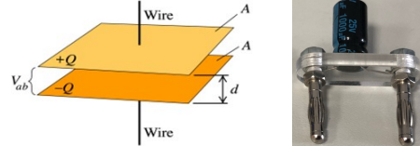
Figure 1: Example of parallel plate and cylindrical capacitors with the one that is used during the experiment
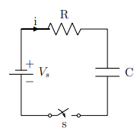
Figure 2: Capacitor charging circuit diagram
The relation of current and voltage with time I(t) (Figure 2), when a capacitor which has a capacitance of C is charged through a resistor R at a fixed voltage V is given by
I(t) = (Vs/R)*e ^{– t/RC} (1)
V_{c} = V_{s} (1 − e ^{– t/RC} ) (2)

Here, Vs is the source voltage, R is the resistance, Vc is the voltage on capacitor and the product of RC is named as the time constant (τ ). The dependence of the current on the capacitance, the resistance and the voltage should be worked out by systematically varying these parameters. In the case of discharging of the capacitor the relation can be seen below
I(t) = -(Vs/R)*e ^{– t/RC} (3)
V_{c} = V_{s} *e ^{– t/RC} (4)

3.Experimental Setup
3.1.Equipment List
- Board x1
- Dc voltage source x1
- Digital multimeter x2
- Capacitor x2
- Resistor x1
- Connection cables x9

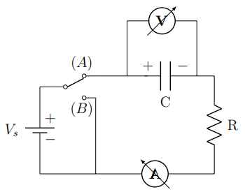
Figure 3: Circuit Diagram

4.Conclusion

Time(s) | I_{exp} (mA) | Vc (volt)
5 | 0.61 | 3.12
10 | 0.432 | 3.61
15 | 0.382 | 3.92
20 | 0.379 | 4.13
25 | 0.374 | 4.42
30 | 0.371 | 4.53
35 | 0.366 | 4.62
40 | 0.363 | 4.81
45 | 0.354 | 4.95
50 | 0.348 | 5.16
55 | 0.342 | 5.24
60 | 0.337 | 5.29
65 | 0.332 | 5.37
70 | 0.329 | 5.43
75 | 0.32 | 5.56
80 | 0.312 | 5.62
85 | 0.311 | 5.67
90 | 0.307 | 5.73
95 | 0.305 | 5.83
100 | 0.297 | 5.92
105 | 0.295 | 5.97
110 | 0.289 | 6.04
Table 1: Charging

Figure 4: Voltage-Time graph of charging

Figure 5:Current-time graph of charging

Time(s) | I_{exp} (mA) | Vc (volt)
5 | 0.374 | 8.8
10 | 0.252 | 3.1
15 | 0.172 | 2.3
20 | 0.142 | 1.74
25 | 0.95 | 1.39
30 | 0.72 | 1.15
35 | 0.55 | 0.94
40 | 0.43 | 0.82
45 | 0.29 | 0.7
50 | 0.24 | 0.62
55 | 0.19 | 0.57
60 | 0.16 | 0.51
65 | 0.13 | 0.48
70 | 0.08 | 0.44
75 | 0.07 | 0.41
80 | 0.06 | 0.39
85 | 0.049 | 0.387
90 | 0.044 | 0.379
95 | 0.041 | 0.365
100 | 0.036 | 0.35
105 | 0.033 | 0.342
110 | 0.028 | 0.335
Table 2: discharging

Figure 6: Voltage-time graph of discharging

Figure 7:Current-time graph of discharging

